A NOVEL SINGLE STAGE SINGLE PHASE RECONFIGURABLE INVERTER TOPOLOGY FOR A SOLAR POWERED HYBRID AC/DC HOME
ABSTRACT
This paper suggests a reconfigurable singlephase inverter topology for a hybrid ac/dc solar powered home. This inverter possesses a single-phase single-stage topology and the main advantage of this converter is that it can perform dc/dc, dc/ac, and grid tie operation, thus reducing loss, cost, and size of the converter. This hybrid ac/dc home has both ac and dc appliances. This type of home helps to reduce the power loss by avoiding unnecessary double stages of power conversion and improves the harmonic profile by isolating dc loads to dc supply side and rest to ac side. Simulation is done in MATLAB/Simulink and the obtained results are validated through hardware implementation using Arduino Uno controller. Such type of solar powered home equipped with this novel inverter topology could become a basic building block for future energy efficient smart grid and microgrid.

BLOCK DIAGRAM FOR PROPOSED SYSTEM
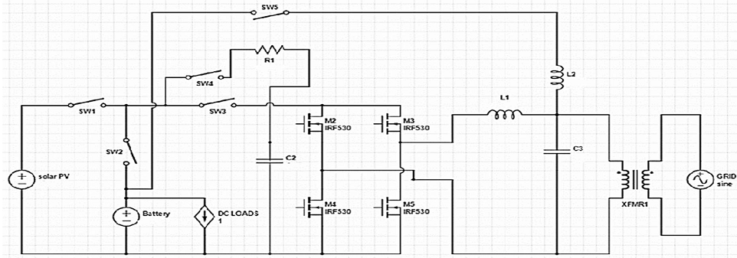
Fig. 1. Schematic of the proposed RSC circuit.
DESIGNG SOFTWARE AND TOOLS:
MAT LAB /SIMULATION Software and simu power systems tools are used. Mainly control system tools, power electronics and electrical elements tools are used.

